Chapter 1

Introduction

Energy Sources and Alternatives
Most of the consumed energy currently is supplied from fossil fuels. The main issue of those sources is sustainability especially with the continuous increase of the demand for energy. Moreover, CO₂ emission from petroleum products creates more environmental problems such as the global warming. The global CO₂ emission has been growing rapidly as shown in Figure ‎1.1 [1], causing dramatic climate changes beside other health issues. However, their low cost is one of the main advantages of fossil fuels in comparison to other sources.

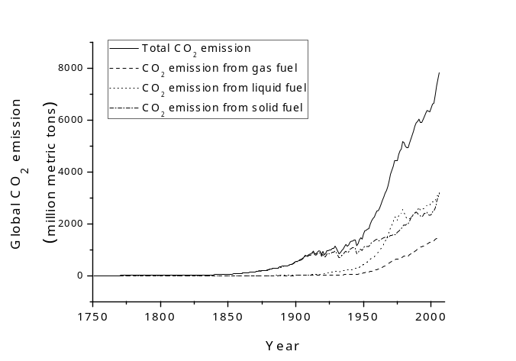
Figure ‎1.1: The rapid increase in the global CO₂ emission from 1950 to 2006.

Therefore, the search for other energy sources is necessary. Nuclear power and renewables seem to be promising candidates to replace fossil fuels. However, each alterative has its own problems such as the treatment of the nuclear waste and the cost of photovoltaics. Good reviews have been published for renewables such as [2, 3].

Solar Cells Development and Challenges
The first reported photogalvanic behaviour was published in 1839 by Beqcuerel [4] after he produced a photocurrent by shining light on an electrode in an electrolyte solution. In 1877 Adams and Day reported a photovoltaic behaviour in selenium [5]. However, in 1954 the Si p-n [6] and Cu_{x}/CdS [7] cells were reported with efficiency ~ 6 % for each device. Solar cells were improved rapidly in the following years in both i) performance, and ii) the variety of the materials used to fabricate the cells [8-10].
Covering only 1 % of the land area on Earth with 10 % efficient solar cells would produce twice the current need of energy worldwide [11]. However, the high cost of solar cells at the present time is a significant barrier to their true mass adoption due to market forces. Certainly, the specific cost ($/W_{p}) of Si solar cells has reduced year-on-year, as is shown in Figure ‎1.2, and this cost reduction is itself driven by increases in high volume manufacturing (Figure ‎1.3) i.e. the “learning rate” of production.

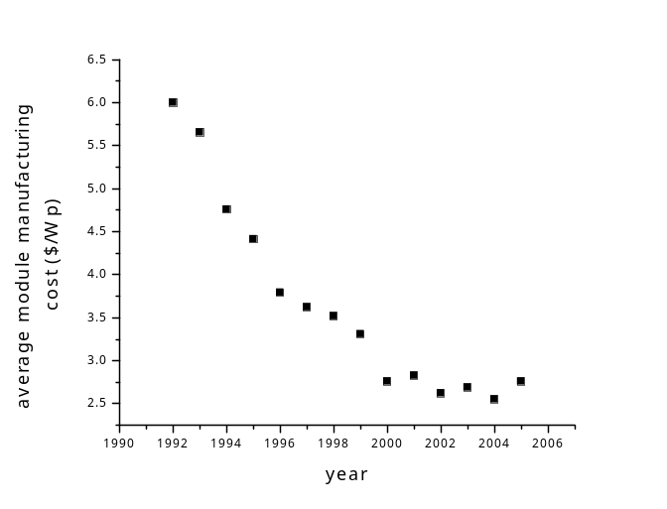

Figure ‎1.2: The average manufacturing cost of Si solar modules in the time range from 1992 to 2005 [12].

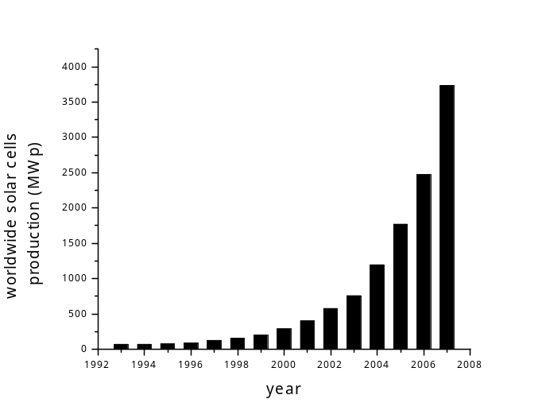
Figure ‎1.3: The increase in PV production from 1993 until 2007 [13].

An alternative means of reducing cost is to substitute the present leading technologies (bulk Si) with products having intrinsically lower cost: it is this which has motivated the drive towards thin-film PV over the past 30 years. Similarly, the promise of even lower cost PV based on organic materials has stimulated research in that area. Figure ‎1.4 shows the historical development of one of a kind lab efficiencies for all of the main types of solar cells. the figure clearly demonstrates that the progress in efficiency improvement, as approximated by a straight line, is remarkably similar for all single junction PV technologies, regardless of their types e.g. single crystal Si improves at 0.52 % while organics improve at 0.43 % per annum, these being the fastest and slowest, Table ‎1.1 shows the full set of slopes. A consequence of this universal – and slow – improvement rate that no one technology has overtaken any other. Nevertheless, efficiency improvements do contribute to a reduction in specific cost, and it is this cost which governs the relative competitiveness of each cell technology.

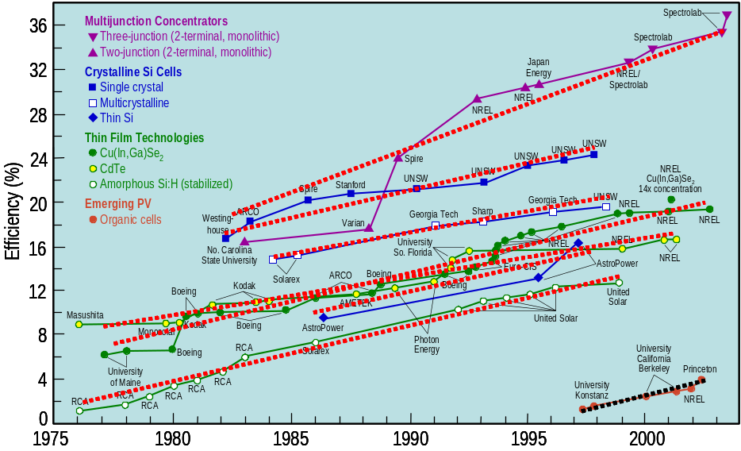

Figure ‎1.4: Progress in different PV materials from 1975 to 2003 [14]. The dashed line is the linear fit of each set of points.

Material | Increase in η / year
Multi-junction concentrators | 0.83
Si single crystal | 0.52
Si multi-crystalline | 0.40
Thin Si | 0.50
Cu(In,Ga)Se₂ | 0.50
CdTe | 0.46
a-Si:H | 0.48
organic | 0.43

Table ‎1.1: The improvement rate of solar cells efficiency using different PV materials, as extracted from Figure ‎1.4.

Chapter 5 reports a study in which the combined effects of CdS processing and CdTe thickness are studies in wedge-shaped samples. This approach enabled accelerated progress by generating up to 30 data device performance points for each processing run: More generally such methods have a role in accelerating research progress in new and emerging solar cell materials.

Solar Resource and Conversion

Solar spectrum
The sun can be assumed to radiate as a black body with T = 5760 K [8], which results in an emitted power density at its surface of ~ 62 MW/m². Based on the distance between Earth and the sun, the power received on the Earth surface can be calculated. However, the spectrum reaching Earth is distorted by the absorption by some elements and compounds in the atmosphere such as water and O₂.
The effect of the atmosphere on the solar spectrum (i.e. the loss in spectrum resulting from the atmosphere) is measured by the Air Mass factor, which is the cosecant of the elevation angle of the sun. The standard illumination is chosen to be Air Mass 1.5 (or AM1.5) which corresponds to an elevation angle of 42°, and power density of ~ 1000 W/m². The AM1.5 spectrum is shown in Figure ‎1.5.

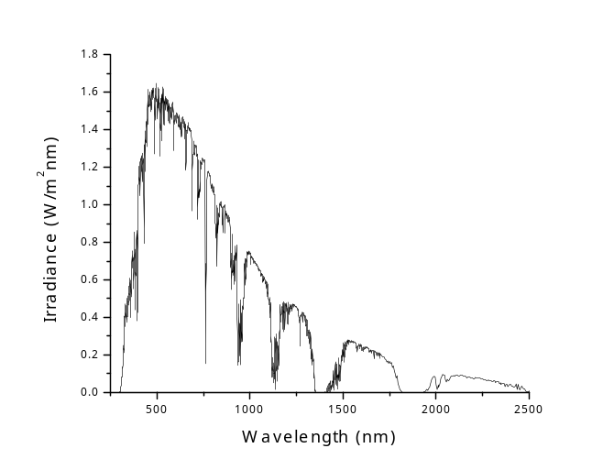

Figure ‎1.5: AM1.5 solar spectrum.

Absorption in semiconductors
Photon absorption in semiconductors depends on nature of the band gap E_{g}. There are two kinds of band gaps for semiconductors: direct and indirect. For direct E_{g}, electrons are elevated across the gap if the photon energy E_{g}. However, in indirect E_{g} lattice vibration (phonons) should be involved in the transition process so that the momentum k is conserved. Figure ‎1.6 shows versus the momentum k diagram for both processes. As a result, the absorption probability is much higher for direct band gap materials compared in indirect bind gap ones. The required thickness for an indirect band gap material to absorb fully the solar spectrum is ~ 20-50 µm whereas it is only 1-3 µm in the case of a direct band gap material [15].

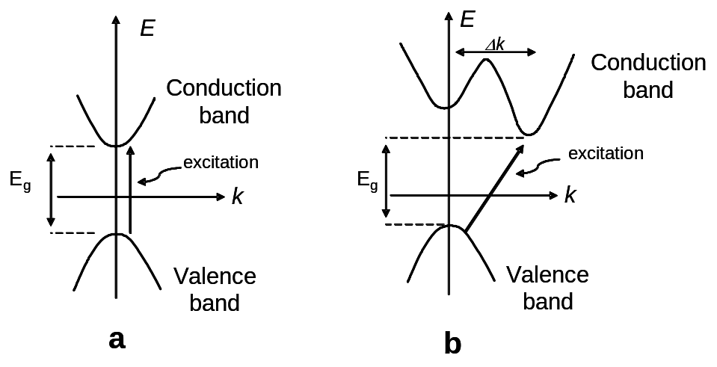

Figure ‎1.6: The direct (a) and indirect (b) band gaps in semiconductors.

Materials for Solar Cells
There are various materials used to fabricate solar cells. Each material has its own advantages and disadvantages. In this Section, a few of them will be discussed briefly. The world record efficiencies for devices using these materials are summarized in Table ‎1.2 [16], and the progress in the performance is shown in Figure ‎1.4.

Material | Best η (%)
Si single crystal | 24.7
Si amorphous | 9.5
GaAs | 25.1
InP | 21.9
CIGS | 18.8

Table ‎1.2: The world record efficiency for the most commonly used PV materials from reference 16.

Si
Si is the most dominant photovoltaic material in the PV market. It has indirect band gap with E_{g} = 1.1 eV. Si is being used in semiconductor applications for a long time. For example, the only widely available homojunction solar cell in 1981 was the Si cell [9]. Extensive research on Si is being conducted, providing a deep knowledge about the properties of this material.
Since it is an indirect band gap material, the thickness needed to fabricate cells is relatively high (~ 200 µm). As a result, high diffusion length of the carries is required, which therefore necessitates having highly pure Si for fabricating solar cells. These factors resulted in increasing the cost price of Si cells. Thinner Si cells were successfully fabricated by changing the material to be completely amorphous. However, their efficiency was not as high as that of the single crystal Si cells.

III-V materials
GaAs is an example of these materials. It has a direct band gap of 1.43 eV which is close to the required value of the optimum efficiency (see Section 1.4.7). Like other III-V materials, GaAs has attracted the attention due to its suitability for electronic applications such as the opto-electronic devices [10]. Because of the high cost of the III-V single crystal cells, they are usually used with concentrators or as space solar cells.
InP, which is another III-V material, is preferable in the space application for its high resistance for radiation. Besides the high cost, the inadequate supply of Ga and the toxicity of As represent the most important limitations for these kinds of solar cell.

CIS
Because of the high cost of Si and III-V solar cells, thin film solar cells are a very promising alternative. Copper indium diselenide (CIS) is one among the PV materials suitable for fabricating thin film solar cells. It has a direct band gap of 1.04 eV, however, this band gap can be engineered by introducing Ga instead of indium leading to cupper indium,gallium diselenide (CIGS). The main disadvantages of CIS are the high cost of indium besides the issue of insufficient sources of Ga.

CdTe
CdTe is a direct band gap semiconductor (E_{g} ~ 1.45 eV) having the zincblend structure and a high absorption coefficient. The first CdTe solar cell was fabricated by Bonnet and Rabenhorst [17] in 1972 with efficiency ~5 %. As seen in Figure ‎1.4, the efficiency have been developed significantly since then, and the current world record for CdTe cells is 16.5 % [18]. Since CdTe/CdS solar cells are the main topic of this thesis, a full review is provided in Chapter 3.

The Scope of This Thesis
This Section outlines briefly the thesis. In Chapter 2, various semiconductor junctions are described besides the basic physics of solar cells. Six methods of determining the ideality factor (n) are reviewed in Section 2.4. The electrical transport mechanisms which were observed in this work (and discussed in detail in Chapter 6) are described in Section 2.5. A new method (Section 2.5.4) was tested to identify the current transport mechanism under the light.
A review of CdTe devices is presented in Chapter 3, including TCO/CdS interface, CdS annealing and its effect on the PV performance, CdCl₂ post-growth treatment (for CdTe), intermixing between CdTe and CdS layers, current transport mechanism in CdTe/CdS junction and back contacts for CdTe devices.
Chapter 4 describes the experimental procedures applied in the thesis. The discussion includes growth techniques, material processing and characterization methods used throughout this work.
The effects of a) pre-growth treatment of the TCO, and b) the post-growth treatment of the CdS on the electrical behaviour of the CdS/TCO bilayer are reported in Chapter 5. Both oxidising and reducing annealing conditions were applied to the samples in order to investigate the annealing-induced changes by recording J-V characteristics for each sample. The chemical changes in the samples were tested by various analytical methods.
In addition, Chapter 5 reports the rapid screening / bevelling method to study the performance of the devices as a function of CdTe thickness. CdS films (in these samples) were post-growth annealed in different ambients in order to examine the effect of this treatment on the PV performance of the complete devices. Therefore, the performance was investigated as a function of a) the CdS treatment, and b) the CdTe thickness.
In Chapter 6 the electrical transport mechanism of the carriers across the CdS/CdTe heterojunction was studied. The J-V-T method was applied to explore the most dominant electrical transport mechanism for three different devices. The transport mechanism was investigated under both forward and reverse bias conditions. Dark and light J-V-T data were recorded for all samples so that the effect of illumination on the transport mechanism was investigated. Testing different devices allowed studying the change in the transport mechanism by changing the a) growth techniques, and b) window layer material.
The last results chapter is Chapter 7 in which the back contact of the CdS/CdTe cells was investigated. The Chapter included a preliminary study, which was undertaken to test the validity of the selected method to measure the barrier height. Five methods for determining the back contact barrier height were reviewed, from which the most suitable method was chosen for investigating other contacts. Au, Sb₂Te₃ and As₂Te₃ contacts were investigated with as-grown, N-P etched and plasma etched CdTe cells.
Finally, the series resistance R_{s} of the cells was determined by several methods in order to choose the most proper method, which was used to determine the barrier height in Chapter 7. The results of this study are reported in Appendix A. A mathematical derivation of the Shockley equation, and the physical meaning of the ideality factor are presented in Appendix B.

References for Chapter 1

